(Approx. 751 words)

Discovering Windows 7 – Part 20
By Neil Stahfest, Vice President, Tacoma Area PC User Group, Washington
October 2011 issue, the Data Line
NCStahfest (at) msn.com
www.tapcug.org

In the days before Microsoft Windows, when we deleted a file the file was gone and there was empty space on the disk was increased. Accidental file deletions could be
a problem if you didn’t have copies. Enter Peter Norton who created a powerful unerase program followed by a number of other similar programs. Norton Utilities was a must have software package for businesses and serious PC users.

With the release of Microsoft Windows, Microsoft introduced the “Recycle Bin”. Now when you deleted a file it didn’t really disappear off your disk. Windows simply changed the file location address from where ever the file was located (i.e. Pictures) to the Recycle Bin. If you discover that you really need a file you just deleted, all you have to do is double-click on the Recycle Bin, select the file or files you want to restore, click on it to select and then click on the Restore button. This causes Windows to change the file address location back to what it was before you deleted the file.
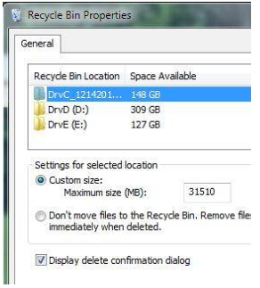
Of course, you have a limited amount of space on your hard drive. By default 5% of your total hard drive space (i.e. 15 GB on a 300 GB drive) is allocated for the Recycle Bin. If you have more than one partition on your hard drive, each partition will have its own Recycle Bin. You can change the size of your Recycle Bin to make it bugger or smaller by right-clicking on the Recycle Bin and selecting “Properties”. In the Recycle Bin Properties window, select the bin location for the partition you want to change and then enter the amount of space you want to reserve for the Recycle Bin (see Figure 1).

Before we move on from the Recycle Bin Properties window, note that there is option that lets you delete files without sending them to the Recycle Bin. This will not delete your Recycle Bin and the amount of disk space it uses. It just allows you to erase files from your disk in one step (with no Recycle Bin safety net). If you are annoyed by Windows asking you if you really want to move a file to the Recycle Bin, you can click to turn off the file delete confirmation dialog.

If you keep deleting files eventually you will fill up your Recycle Bin. At that point Windows will start to delete the oldest files in the Recycle Bin from your hard drive. Files deleted from the Recycle Bin are truly gone, creating empty space on your hard drive. Actually you may still be able to still restore them with third party file un-erase programs but that’s beyond the scope of this article.

So how do you create empty space on your hard drive by deleting files you no longer need? Well, start by deleting them (sending the files to the Recycle Bin). Then right click on the Recycle Bin and left click on “Empty Recycle Bin” (Figure 2). The files are now gone and you have more space on your hard drive.

This brings up the question, should I periodically empty my Recycle Bin? That’s really an individual choice but my experience has been when I accidentally delete a file I discover the mistake within minutes or at minutes or at most a few days of the deletion. I usually delete everything that has been in my Recycle Bin for more than a week.
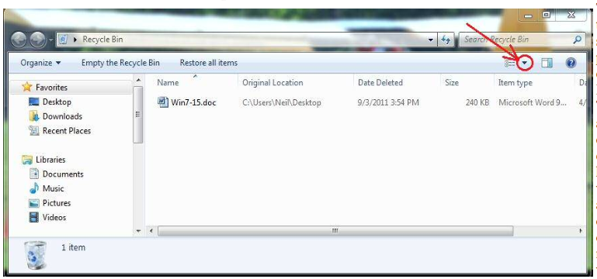
Figure 2

You may wonder how you know how long a file has been in the Recycle Bin. When you open the Recycle Bin you may or may not see the date the file was deleted. If you do not, click on the small triangle in the upper right corner of the Recycle Bin window as shown in Figure 2 (circled in red).

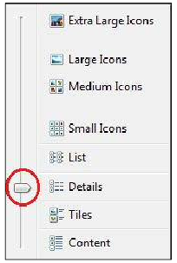
In the pop-up window that appears (Figure 3), select “Details” (shown circled in red) and now you should see the “Date Deleted” column.

As you can see, the Recycle Bin is a pretty useful tool. You can use it as it comes, out of the box so to speak, or you can alter it to change its size to suite the way you work.
For more information click on the Windows Start button, select “Help and Support and type “Recycle Bin” in the search box.

Figure 3

